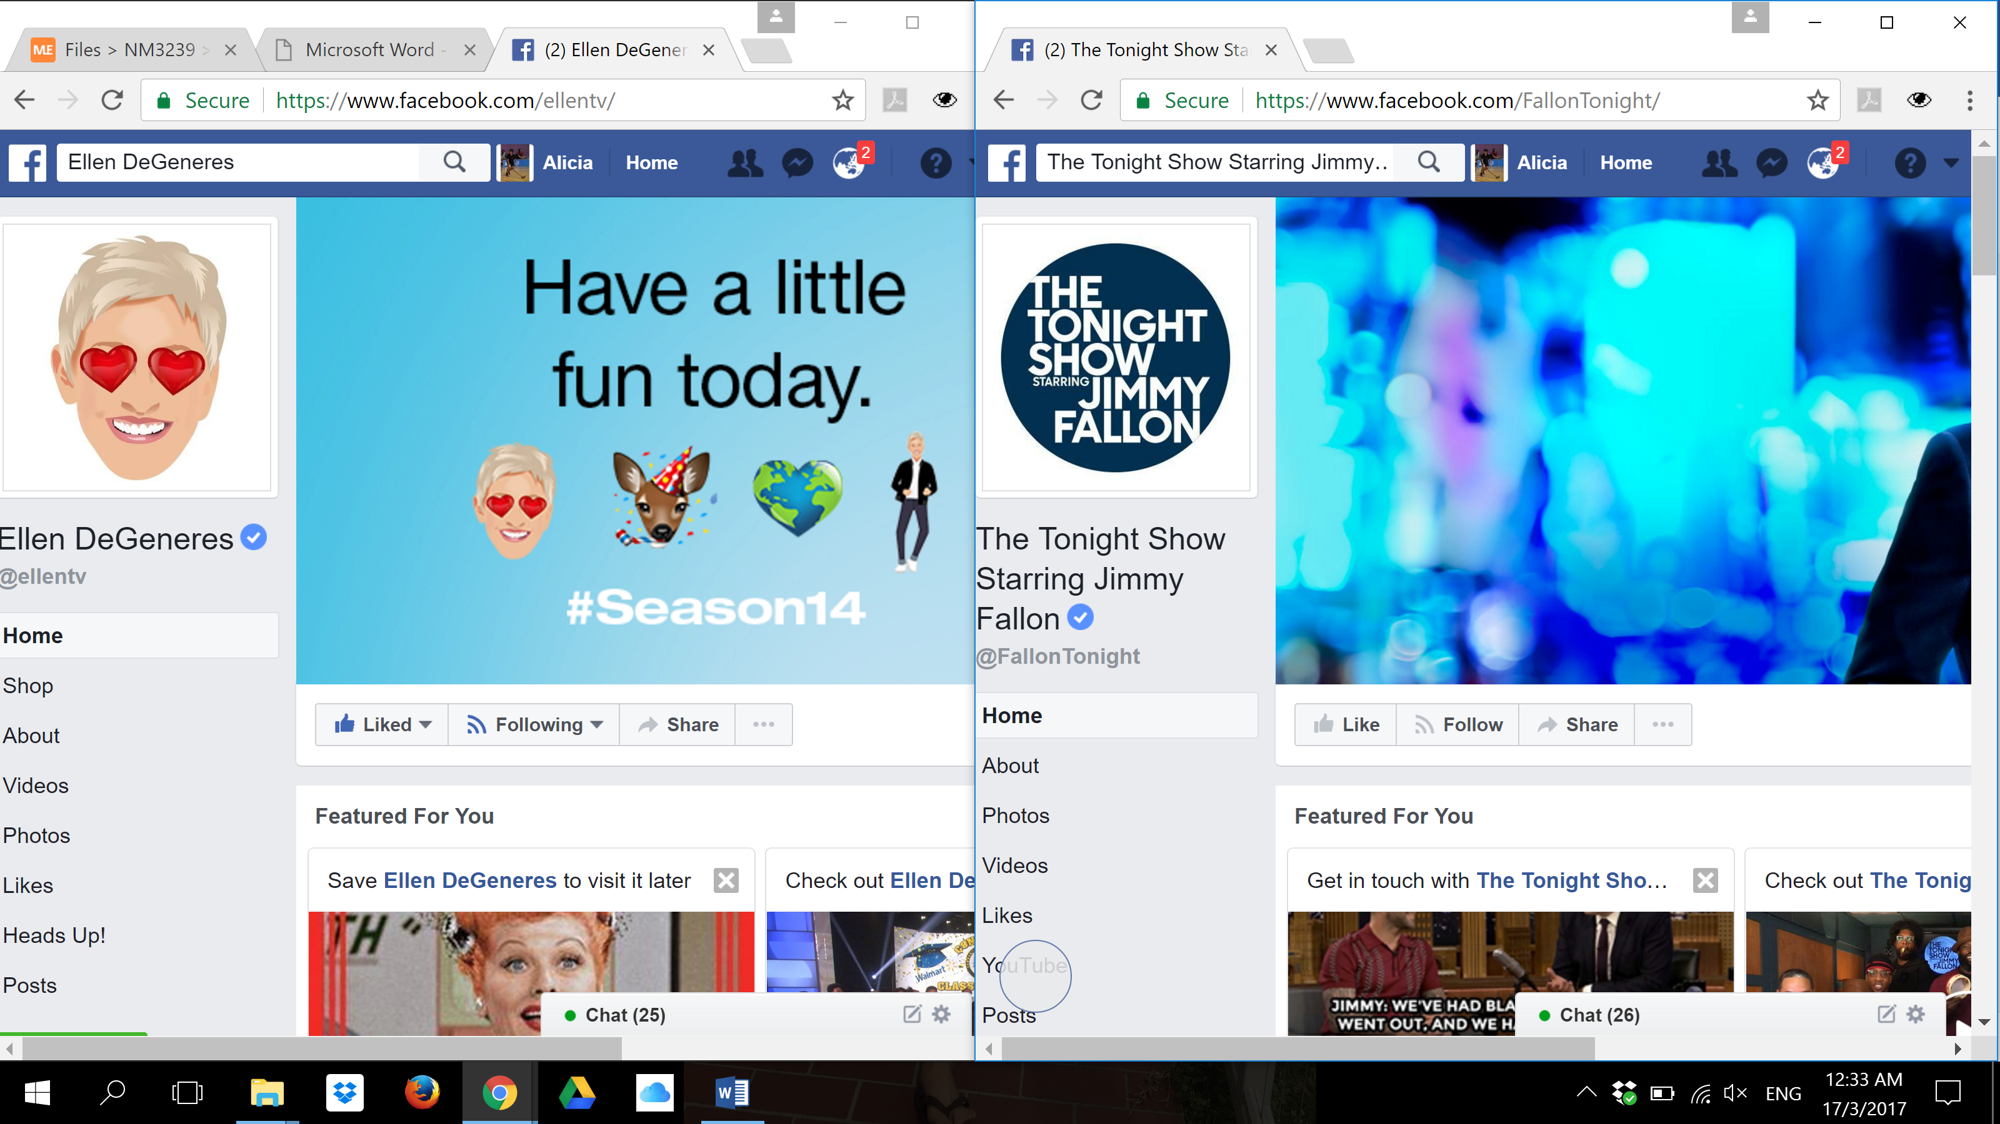

|  |
| --- |
| ALICIA SOH SU XIAN (A0114334U) |
| Ellen DeGeneres or Jimmy Fallon? |
| The Ellen DeGeneres Show & The Tonight Show by Jimmy Fallon Facebook Page Analysis |

|  |
| --- |
| Alicia Soh Su Xian  3-17-2017 |

Table of Contents

1. Brief Introduction of Dataset 2

• Who uploads photos and posts more frequently? 2

• The average numbers of likes (or reactions Like, Love, Haha, Wow, Sad, Angry), shares and comments for different posts (photos, videos, and links). 2

• Analyze the comments stream to gain insights. What are the most common topics being discussed? 2

• What similarities and differences can you identify between fans of these two selected pages? 2

• Can you tell if fans are particularly happy or upset about anything? 2

• Can you find anything surprising or trending? Did you notice any hidden information or patterns from the comparisons/graphs? 3

5. Develop an emotional level indicator 3

• What are your overall conclusions? What are your recommendations or predictions? 3

• What are some new things that you learnt from the dataset? What surprised you? What inspired you? 3

• Search for external sources on the WWW for insights and other data sources. 3

• What challenges arose while working with social media data? 4

References 5

Appendix A 6

Appendix B 9

# 1. Brief Introduction of Dataset

Using Netlytic (Netlytic, 2017), Quintly (Quintly, 2017), Facebook Graph API (Facebook For Developers, 2017) as well as data from FanPageKarma.com (FanPageKarma, 2017) to collect publicly available Facebook data (posts, photos, comments, likes, etc.) from Ellentv and FallonTonight Facebook page to conduct analysis for the various questions below and provide recommendations for users on the two stand-up comedy shows.

|  |  |  |
| --- | --- | --- |
| Netlytic .csv datas: (Collected for 3 days – 15th March to 17th March 2017) | Quintly .pdf and .jpeg datas: (Collected from 15th February to 15th March 2017) | Facebook Graph API .csv datas: (Refer to References for Facebook Graph API URLs) |

# • Who uploads photos and posts more frequently?

Based on the key metrics (Refer to Figure 1 in Appendix A) from Quintly and chart (Refer to Figure 2 in Appendix A) from Netlytic, it shows that Ellentv posts more own posts more frequently than compared to The Tonight Show. As according to Netlytic, Ellentv has more photo posts as compared to FallonTonight. However, both shows have the same number of status posts.

# • The average numbers of likes (or reactions Like, Love, Haha, Wow, Sad, Angry), shares and comments for different posts (photos, videos, and links).

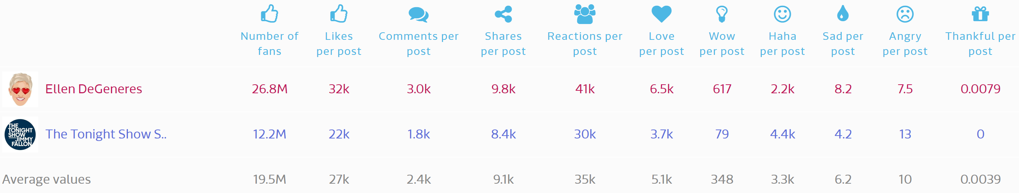

According to FanPageKarma (FanPageKarma, 2017), the total average number of likes, shares and comments for all posts is as stated above (Refer to Figure 3 in Appendix A). Upon further analysis (Refer to Figure 4 in Appendix A), the total average number of reactions for Ellentv for videos is 60,586, 53,472 for pictures, 13,652 for links and 2,097 for statuses. As for FallonTonight, the total average number of reactions for videos is 103,250, 19,313 for pictures, 18,036 for links and 2,955 for statuses.

# • Analyze the comments stream to gain insights. What are the most common topics being discussed?

Based on the charts (Refer to Figure 5 and Figure 7 in Appendix A) from Netlytic, it shows that the comment stream and topics from Ellentv is more towards having a positive outlook on life, love, world and happiness related texts than compared to FallonTonight. On the other hand, the comment stream from FallonTonight are more towards celebrities including Fallon himself as well as about the show. Moreover, the topics from Ellentv seems to be more female oriented due to the high presence of the text ‘women’. On the other hand, the topics from FallonTonight seem to be more diverse.

# • What similarities and differences can you identify between fans of these two selected pages?

Based on the diagram (Refer to Figure 6 in Appendix A) from Netlytic, for Ellentv, majority of the fans reply on the fan page and there is a more interaction. On the other hand, majority of the fans on FallonTonight fan page do not reply on the fan page and there is minimal interaction. Thus, the difference is that, the fans from Ellentv are more interactive and participative than compared to FallonTonight.

# • Can you tell if fans are particularly happy or upset about anything?

Based on the chart (Refer to Figure 8 in Appendix A), for Ellentv and FallonTonight, the positive feelings are referring to how ‘hilarious’ and ‘silly’ the show is and evoking ‘good’ and ‘happy’ feelings towards fans. Upon further analysis of the negative feelings that fans from Ellentv mentioned, they are referring to how ‘Ellen show cheers them up on a **bad** day’. However, as for FallonTonight, the negative feelings are referring to how the fans are ‘**tired** of watching the same games’ that Jimmy Fallon has on his show and the fans suggests that he should add in new elements into the show. There are also several misinterpretations of the negative feelings. For example, one of the fans mentioned that they are ‘**tired** and **angry’** of Donald Trump speaking negatively of Jimmy Fallon and causing political drama.

# • Can you find anything surprising or trending? Did you notice any hidden information or patterns from the comparisons/graphs?

Based on the data from Quintly (Refer to Figure 9 in Appendix A), there are very sudden increases in interaction rate for FallonTonight followed by a sudden increase in fan change rate. On the day when there are high interaction rates, FallonTonight posted videos/ photos that fans are interested in (e.g. on the 17th February, FallonTonight posted a video clip of the show featuring Robert Irwin (the late Steve Irwin’s son)). As these posts catches fans’ and the public’s interest, it resulted in high interaction rates and following a change in fans change rates.

# 5. Develop an emotional level indicator

*(Refer to Appendix B for grep commands and results on Cygwin)*

|  |  |  |
| --- | --- | --- |
|  | **Ellentv** | **FallonTonight** |
| **Angry** | 4 | 2 |
| **Fear** | 8 | 0 |
| **Surprise** | 12 | 0 |
| **Disgust** | 0 | 2 |
| **Happy** | 98 | 20 |
| **Sad** | 45 | 4 |

According to the table above and chart (Refer to Figure 10 in Appendix A), it shows that both Ellentv and FallonTonight have the most number of occurrences of ‘happy’ related words. There are negligible occurrences of ‘fear’ and ‘angry’ related words for Ellentv and ‘disgust’ and ‘angry’ for FallonTonight. Thus, both shows are effective in evoking a ‘happy’ emotion to their fans as the number of occurrences of ‘happy’ related words trumps the words that evoke negative feelings. However, Ellentv has more a lot more ‘happy’ related word counts than compared to FallonTonight. As such, it is possible to conclude that the fans experience more happy thoughts or positive feelings on Ellentv.

# • What are your overall conclusions? What are your recommendations or predictions?

From the data and analyses above, I can conclude that both shows are indeed entertainment shows that is capable of lighting up someone’s day. I would recommend Ellentv towards people who are seeking for happiness, having a positive outlook on life, needing a little boost/ positive thought. In addition, The Ellentv is known to be friendly towards female audience. As for FallonTonight, I would recommend towards people who are interested to watch celebrity interviews and games. I predict that both shows will experience a continuous steady increase in fans as well as interaction rate on the Facebook page.

# • What are some new things that you learnt from the dataset? What surprised you? What inspired you?

I have learnt that it is important for these entertainment shows to cater to its audiences in order for them to compete with their competitors. It is also important to have a variety of programmes in the show as this would make the show less ‘**boring’**. What surprised me was, although Ellentv was catered more towards females, there are also male fans that actively participate and interact in the Facebook fan page as well as support the show. I believe that happiness helps to bring out the best in oneself as it allows the mind to nurture positive qualities and as such, I feel inspired to spread these entertainment shows to anyone who constantly face trouble in trying to stay positive in life or are currently feeling down as I understand that these shows can bring light to someone’s life.

# • Search for external sources on the WWW for insights and other data sources.

Ellentv would be suitable for women and this is supported by The Hollywood Reporter where it states that Ellentv fans consists of women (Guthrie, 2016). Moreover, the aim of Ellentv, as reported by Los Angeles Times, is to make people feel good and to spread happiness (Los Angeles Times, 2013). This supports the analyses and findings of the social media data collected from the Facebook page. As for FallonTonight, through analyses, the show is mainly catered towards celebrities’ interviews and games. This is supported by external sources where it states that The Tonight Show stars Jimmy Fallon interviews celebrities and has many recurring segments and games that are played with the various celebrity guests (Wikipedia, 2017).

# • What challenges arose while working with social media data?

There are large amount of irrelevance in the data (e.g. in the comments section of the posts in Ellentv, fans would advertise certain information that is not related to Ellentv). This would make the analysis of data skewed. If irrelevance are present at large quantities, analysis will be inaccurate. Secondly, to have a more accurate analysis, collecting data from more than one social media platform is beneficial. In addition, different social media platforms allow users to perform different actions. For example, Twitter allows users to retweet and tweet. However, these actions are not possible for Instagram. As such, these different actions must be interpreted differently.

1000 words – 3 pages

# References

Facebook For Developers. (2017). *Facebook For Developers*. Retrieved from Facebook For Developers: https://developers.facebook.com/

FanPageKarma. (2017). *FanPageKarma*. Retrieved from FanPageKarma: http://www.fanpagekarma.com/

Guthrie, M. (2016, April 1). *'The Ellen DeGeneres Show' Renewed Through 2020*. Retrieved from The Hollywood Reporter: http://www.hollywoodreporter.com/news/ellen-degeneres-show-renewed-2020-851889

Los Angeles Times. (2013, April 5). *For Ellen DeGeneres, things are going along nicely*. Retrieved from Los Angeles Times: http://www.latimes.com/entertainment/envelope/cotown/la-et-ct-for-ellen-degeneres-things-are-going-along-nicely-20130405-dto-htmlstory.html

Netlytic. (2017). *Netlytic*. Retrieved from Netlytic: https://netlytic.org/

Quintly. (2017). *Quintly*. Retrieved from Quintly: https://www.quintly.com/

Wikipedia. (2017, March 18). *The Tonight Show Starring Jimmy Fallon*. Retrieved from Wikipedia: https://en.wikipedia.org/wiki/The_Tonight_Show_Starring_Jimmy_Fallon

Facebook Graph API:

<https://graph.facebook.com/v2.8/ellentv/posts/?fields=message,link,permalink_url,created_time,type,name,id,comments.limit(5).summary(true),shares,likes.limit(0).summary(true),reactions.limit(0).summary(true)&limit=100&access_token=EAACEdEose0cBAHvf2Bt85S9AcGGjCbVMAjmVELSLpqWAX87MbVWQvPKcerGMMB7E8RINLxBhCRP9CsZBeGjV3K7ap24Uj288FfRoMyh9mM5JfVlIrX2pZBedSDEDrJqZBEZCcUii82LWGTCabhkbzAVRQU4YYEfOUJjd1ZA7fEoyn66CdhhBw>

<https://graph.facebook.com/v2.8/FallonTonight/posts/?fields=message,link,permalink_url,created_time,type,name,id,comments.limit(5).summary(true),shares,likes.limit(0).summary(true),reactions.limit(0).summary(true)&limit=100&access_token=EAACEdEose0cBAHvf2Bt85S9AcGGjCbVMAjmVELSLpqWAX87MbVWQvPKcerGMMB7E8RINLxBhCRP9CsZBeGjV3K7ap24Uj288FfRoMyh9mM5JfVlIrX2pZBedSDEDrJqZBEZCcUii82LWGTCabhkbzAVRQU4YYEfOUJjd1ZA7fEoyn66CdhhBw>

# Appendix A

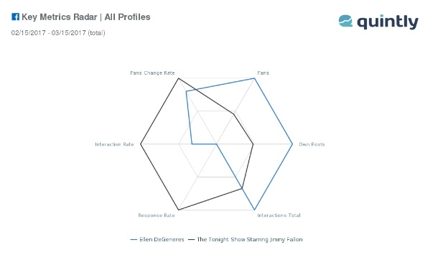

Figure 1

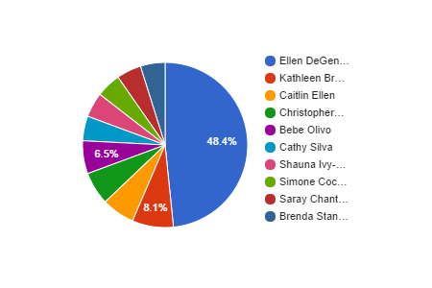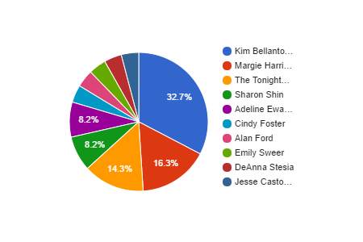

Ellentv (Ellen DeGeneres) FallonTonight (Jimmy Fallon)

Figure 2



Figure 3

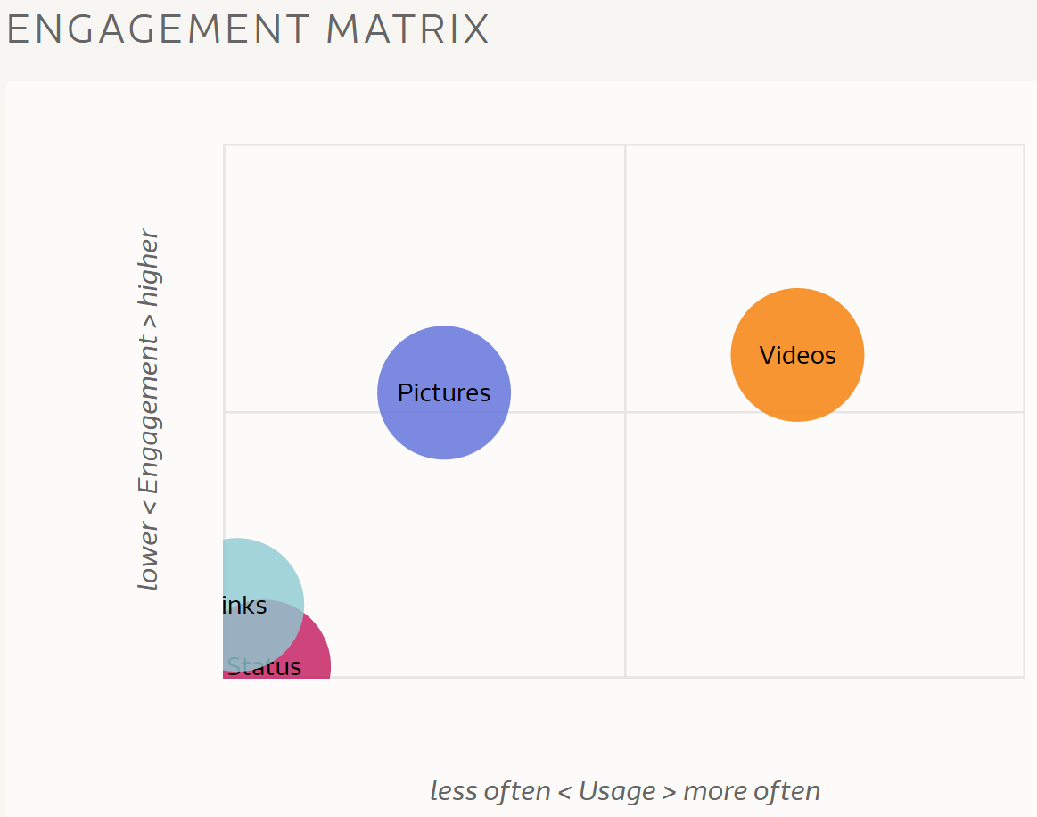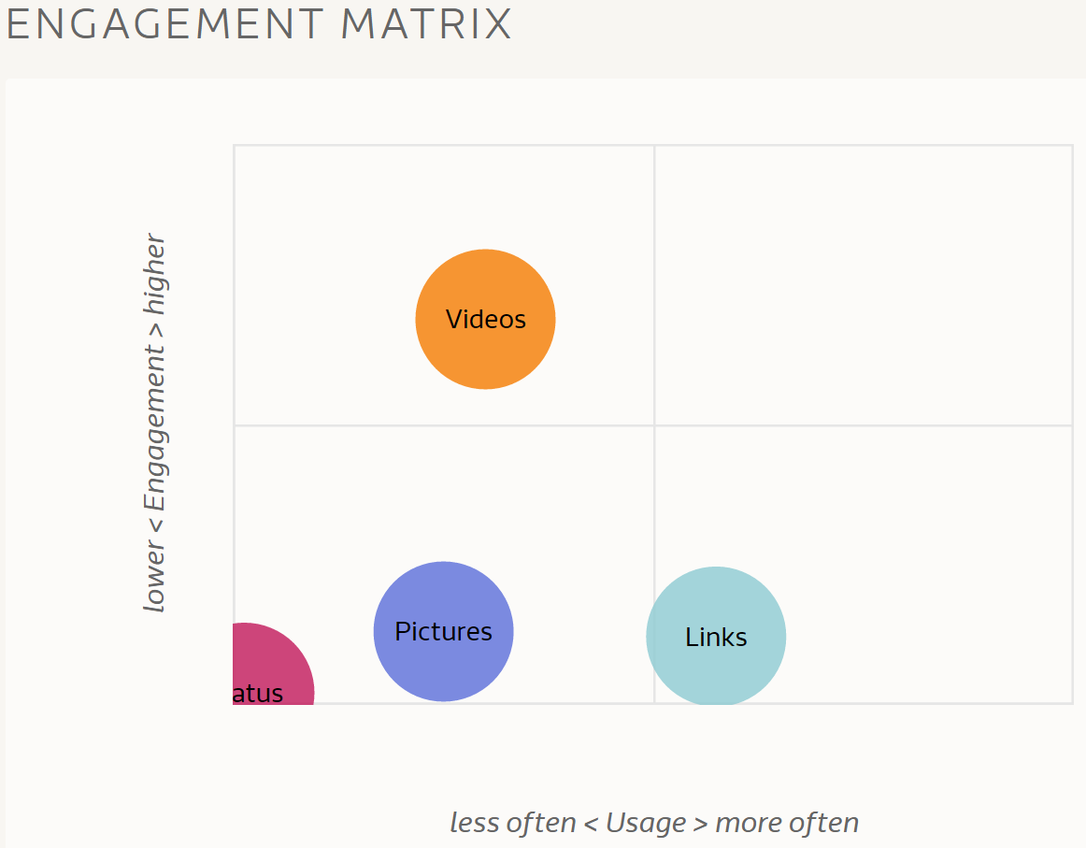

Ellentv (Ellen DeGeneres) FallonTonight (Jimmy Fallon)

Figure 4

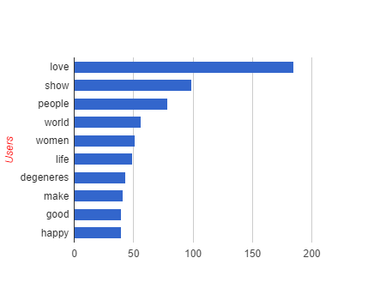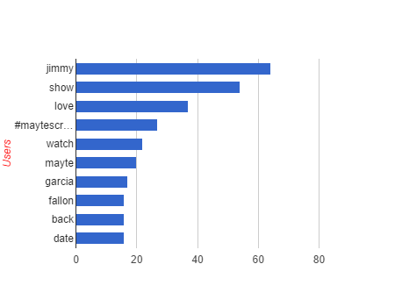

Ellentv (Ellen DeGeneres) FallonTonight (Jimmy Fallon)

Figure 5

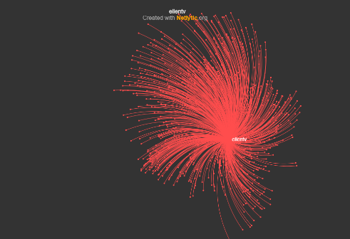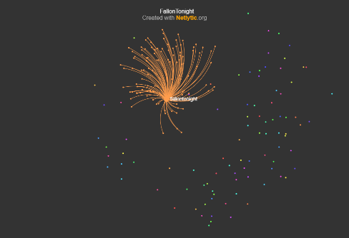

Ellentv (Ellen DeGeneres) FallonTonight (Jimmy Fallon)

Figure 6

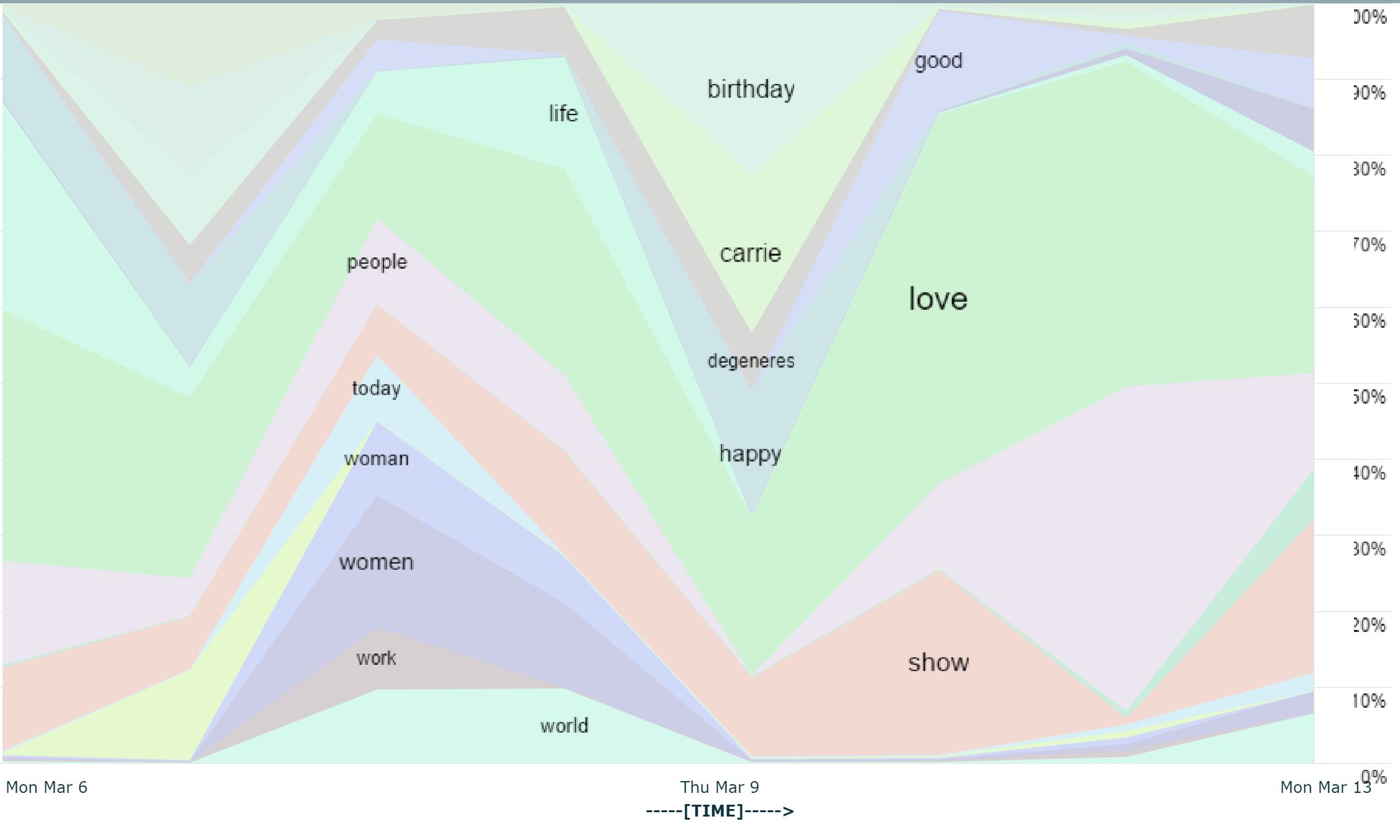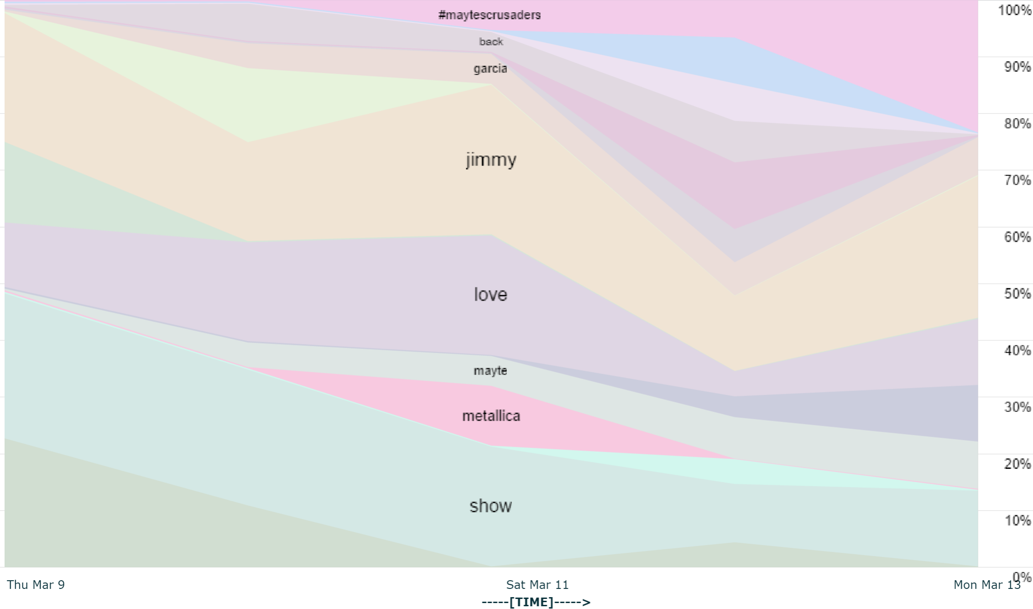

Ellentv (Ellen DeGeneres) FallonTonight (Jimmy Fallon)

Figure 7

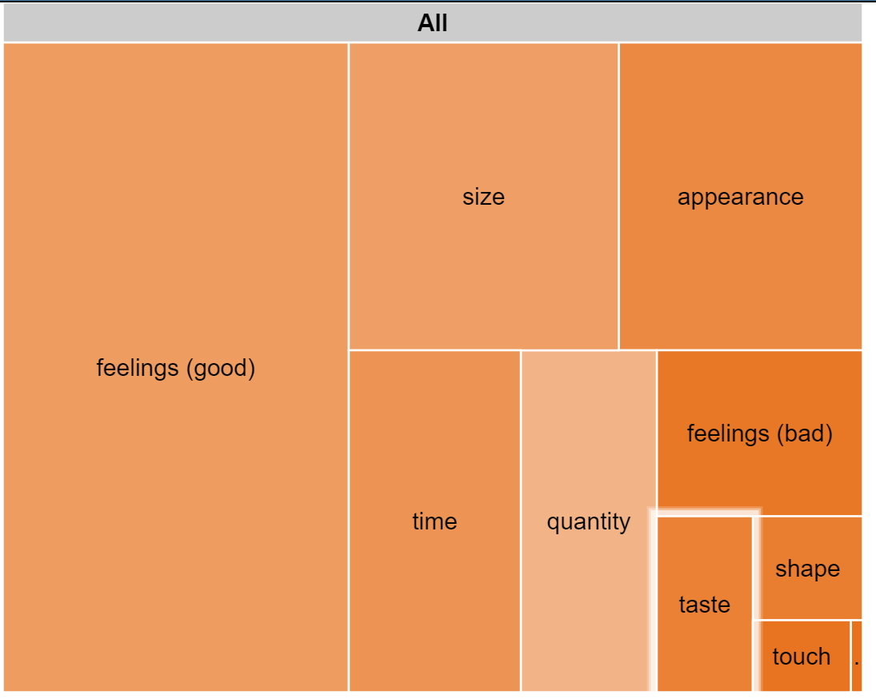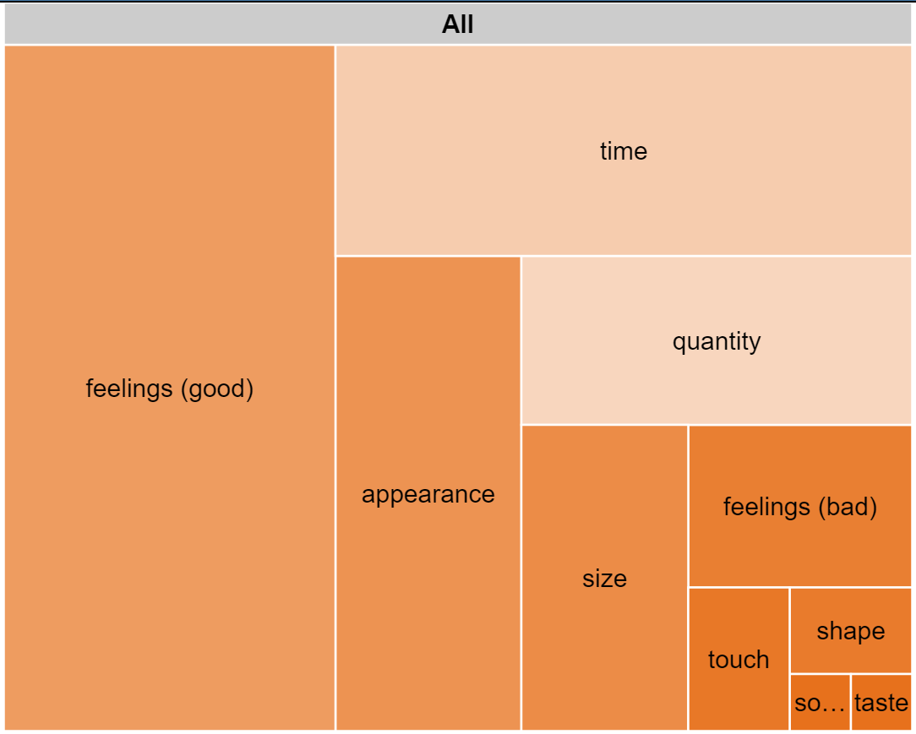

Ellentv (Ellen DeGeneres) FallonTonight (Jimmy Fallon)

Figure 8

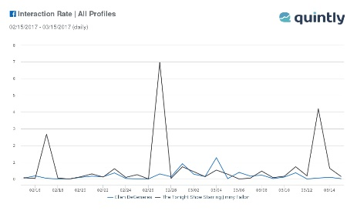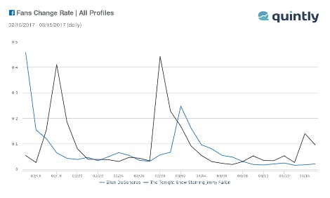

Ellentv (Ellen DeGeneres) FallonTonight (Jimmy Fallon)

Figure 9

Figure 10

# Appendix B

**For Ellentv:**

Owner@DESKTOP-U3VU8H0 /cygdrive/c/Users/Owner/Dropbox/Y4S2/NM3239/Assignment 2/Raw Data

$ grep -Eino "\banger|\bangry|\bangst[a-z]*" ellentv.csv| wc -l

4

Owner@DESKTOP-U3VU8H0 /cygdrive/c/Users/Owner/Dropbox/Y4S2/NM3239/Assignment 2/Raw Data

$ grep -Eino "\bfear[a-z]*" ellentv.csv| wc -l

8

Owner@DESKTOP-U3VU8H0 /cygdrive/c/Users/Owner/Dropbox/Y4S2/NM3239/Assignment 2/Raw Data

$ grep -Eino "\bsurpris[a-z]*" ellentv.csv| wc -l

12

Owner@DESKTOP-U3VU8H0 /cygdrive/c/Users/Owner/Dropbox/Y4S2/NM3239/Assignment 2/Raw Data

$ grep -Eino "\bdisgust[a-z]*" ellentv.csv| wc -l

0

Owner@DESKTOP-U3VU8H0 /cygdrive/c/Users/Owner/Dropbox/Y4S2/NM3239/Assignment 2/Raw Data

$ grep -Eino "\bhappi[a-z]*|\bhappy[a-z]*" ellentv.csv| wc -l

98

Owner@DESKTOP-U3VU8H0 /cygdrive/c/Users/Owner/Dropbox/Y4S2/NM3239/Assignment 2/Raw Data

$ grep -Eino "\bsad[a-z]*" ellentv.csv| wc -l

45

**For FallonTonight:**

Owner@DESKTOP-U3VU8H0 /cygdrive/c/Users/Owner/Dropbox/Y4S2/NM3239/Assignment 2/Raw Data

$ grep -Eino "\banger|\bangry|\bangst[a-z]*" FallonTonight.csv| wc -l

2

Owner@DESKTOP-U3VU8H0 /cygdrive/c/Users/Owner/Dropbox/Y4S2/NM3239/Assignment 2/Raw Data

$ grep -Eino "\bfear[a-z]*" FallonTonight.csv| wc -l

0

Owner@DESKTOP-U3VU8H0 /cygdrive/c/Users/Owner/Dropbox/Y4S2/NM3239/Assignment 2/Raw Data

$ grep -Eino "\bsurpris[a-z]*" FallonTonight.csv| wc -l

0

Owner@DESKTOP-U3VU8H0 /cygdrive/c/Users/Owner/Dropbox/Y4S2/NM3239/Assignment 2/Raw Data

$ grep -Eino "\bdisgust[a-z]*" FallonTonight.csv| wc -l

2

Owner@DESKTOP-U3VU8H0 /cygdrive/c/Users/Owner/Dropbox/Y4S2/NM3239/Assignment 2/Raw Data

$ grep -Eino "\bhappi[a-z]*|\bhappy[a-z]*" FallonTonight.csv| wc -l

20

Owner@DESKTOP-U3VU8H0 /cygdrive/c/Users/Owner/Dropbox/Y4S2/NM3239/Assignment 2/Raw Data

$ grep -Eino "\bsad[a-z]*" FallonTonight.csv| wc -l

4